Week 3 Penetration Testing Report
Full Name: Chirag Suthar
Program: HCPT
Date: 03-03-2025

Introduction
This report hereby describes the proceedings and results of a Black Box security assessment conducted against Week 3 Labs. The report hereby lists the findings and corresponding best practice mitigation actions and recommendations.
- Objective
The objective of the assessment was to uncover vulnerabilities in the Week 3 Labs and provide a final security assessment report comprising vulnerabilities, remediation strategy, and recommendation guidelines to help mitigate the identified vulnerabilities and risks during the activity.
- Scope
This section defines the scope and boundaries of the project.
Cross Origin Resource Sharing, Cross-Site Request Forgery
Application Name
- Summary
Outlined is a Black Box Application Security assessment for Week 3 Labs.

Total number of Sub-labs: 16 Sub-labs

High | Medium | Low
5 | 4 | 4

High - Number of Sub-labs with hard difficulty level Medium - Number of Sub-labs with medium difficulty level, Low - Number of Sub-labs with Easy difficulty level

  - Cross Origin Resource Sharing (CORS)
    - CORS With Arbitrary Origin

Reference | Risk Rating
CORS With Arbitrary Origin | Low
Tools Used
Google Chrome and Burp Suite
Vulnerability Description
Cross-origin resource sharing (CORS) is a browser mechanism which enables controlled access to resources located outside of a given domain. It extends and adds flexibility to the same-origin policy. However, it also provides potential for cross-domain based attacks, if a website’s CORS policy is poorly configured and implemented. The CORS protocol uses some HTTP headers that define trusted web origins and associated properties such as whether authenticated access is permitted. Many modern websites use CORS to allow access from subdomains and trusted third parties. Sometimes because of mistakes of developers’ attackers can use misconfiguration to exploit vulnerability.
How It Was Discovered
I found this vulnerability by manually writing Origin payload by intercepting it in the Burp Suite.
Vulnerable URLs
https://labs.hacktify.in/HTML/cors_lab/lab_1/index.php
Consequences of not Fixing the Issue
Attackers would treat many victims to visit the attacker’s website, if victim is logged in, then his personal information is recorded on attacker's server. Attacker can perform any action in the user's account, bypassing CSRF tokes
Suggested Countermeasures
- Proper configuration of cross-domain requests : If a web resource contains sensitive information, the origin should be properly specified in the Access-Control-Allow-Origin header.
- Only allow trusted sites : Dynamically reflecting origins from cross-domain requests without validation is readily exploitable and should be voided.
- Avoid whitelisting null : Avoid using the header Access-Control-Allow-Origin: null . Cross-domain resource calls from internal documents and sandboxed requests can specify the null origin. CORS headers should be properly defined in respect of trusted origins for private and public servers.
- Avoid wildcards in internal networks : Avoid using wildcards in internal networks. Trusting network configuration alone to protect internal resources is not sufficient when internal browsers can access untrusted external domains.
References
- https://portswigger.net/web-security/cors
- https://owasp.org/www-community/attacks/CORS_OriginHeaderScrutiny
- https://developer.mozilla.org/en-US/docs/Web/HTTP/CORS
Payload Used
origin:attacker.com

Proof of Concept
This section contains proof of the above vulnerabilities as the screenshot of the vulnerability of the lab.
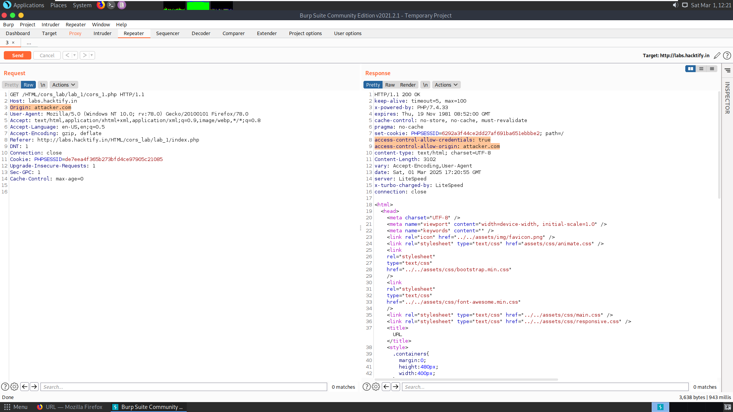
    - CORS with Null Origin

Reference | Risk Rating
CORS With Null Origin | Low
Tools Used
Google Chrome and Burp Suite
Vulnerability Description
Cross-origin resource sharing (CORS) is a browser mechanism which enables controlled access to resources located outside of a given domain. It extends and adds flexibility to the same-origin policy. However, it also provides potential for cross-domain based attacks, if a website’s CORS policy is poorly configured and implemented. The CORS protocol uses some HTTP headers that define trusted web origins and associated properties such as whether authenticated access is permitted. Many modern websites use CORS to allow access from subdomains and trusted third parties. Sometimes because of mistakes of developers’ attackers can use misconfiguration to exploit vulnerability.
How It Was Discovered
I found this vulnerability by manually writing Origin payload by intercepting it in the Burp Suite.
Vulnerable URLs
https://labs.hacktify.in/HTML/cors_lab/lab_2/index.php
Consequences of not Fixing the Issue
Attackers would treat many victims to visit the attacker’s website, if victim is logged in, then his personal information is recorded on attacker's server. Attacker can perform any action in the user's account, bypassing CSRF tokes
Suggested Countermeasures
- Proper configuration of cross-domain requests : If a web resource contains sensitive information, the origin should be properly specified in the Access-Control-Allow-Origin header.
- Only allow trusted sites : Dynamically reflecting origins from cross-domain requests without validation is readily exploitable and should be voided.
- Avoid whitelisting null : Avoid using the header Access-Control-Allow-Origin: null . Cross-domain resource calls from internal documents and sandboxed requests can specify the null origin. CORS headers should be properly defined in respect of trusted origins for private and public servers.
- Avoid wildcards in internal networks : Avoid using wildcards in internal networks. Trusting network configuration alone to protect internal resources is not sufficient when internal browsers can access untrusted external domains.
References
- https://portswigger.net/web-security/cors
- https://owasp.org/www-community/attacks/CORS_OriginHeaderScrutiny
- https://developer.mozilla.org/en-US/docs/Web/HTTP/CORS
Payload Used
origin:attacker.com

Proof of Concept
This section contains proof of the above vulnerabilities as the screenshot of the vulnerability of the lab.
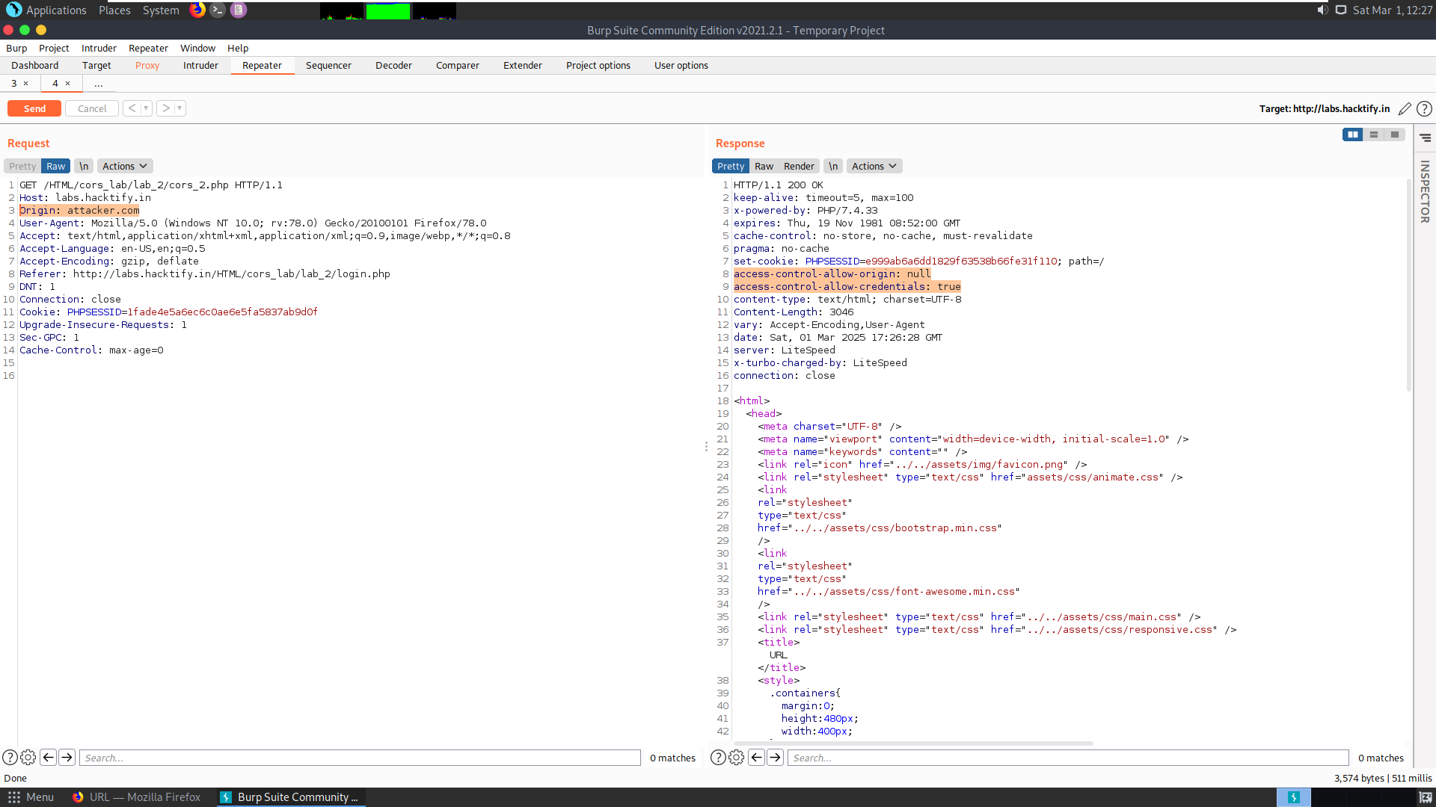
    - CORS with prefix match

Reference | Risk Rating
CORS With prefix match | Medium
Tools Used
Google Chrome and Burp Suite
Vulnerability Description
Cross-origin resource sharing (CORS) is a browser mechanism which enables controlled access to resources located outside of a given domain. It extends and adds flexibility to the same-origin policy. However, it also provides potential for cross-domain based attacks, if a website’s CORS policy is poorly configured and implemented. The CORS protocol uses some HTTP headers that define trusted web origins and associated properties such as whether authenticated access is permitted. Many modern websites use CORS to allow access from subdomains and trusted third parties. Sometimes because of mistakes of developers’ attackers can use misconfiguration to exploit vulnerability.
How It Was Discovered
I found this vulnerability by manually writing Origin payload by intercepting it in the Burp Suite.
Vulnerable URLs
https://labs.hacktify.in/HTML/cors_lab/lab_3/index.php
Consequences of not Fixing the Issue
Attackers would treat many victims to visit the attacker’s website, if victim is logged in, then his personal information is recorded on attacker's server. Attacker can perform any action in the user's account, bypassing CSRF tokes
Suggested Countermeasures
- Proper configuration of cross-domain requests : If a web resource contains sensitive information, the origin should be properly specified in the Access-Control-Allow-Origin header.
- Only allow trusted sites : Dynamically reflecting origins from cross-domain requests without validation is readily exploitable and should be voided.
- Avoid whitelisting null : Avoid using the header Access-Control-Allow-Origin: null . Cross-domain resource calls from internal documents and sandboxed requests can specify the null origin. CORS headers should be properly defined in respect of trusted origins for private and public servers.
- Avoid wildcards in internal networks : Avoid using wildcards in internal networks. Trusting network configuration alone to protect internal resources is not sufficient when internal browsers can access untrusted external domains.
References
- https://portswigger.net/web-security/cors
- https://owasp.org/www-community/attacks/CORS_OriginHeaderScrutiny
- https://developer.mozilla.org/en-US/docs/Web/HTTP/CORS
Payload Used
origin:hacktify.in,attacker.com

Proof of Concept
This section contains proof of the above vulnerabilities as the screenshot of the vulnerability of the lab.
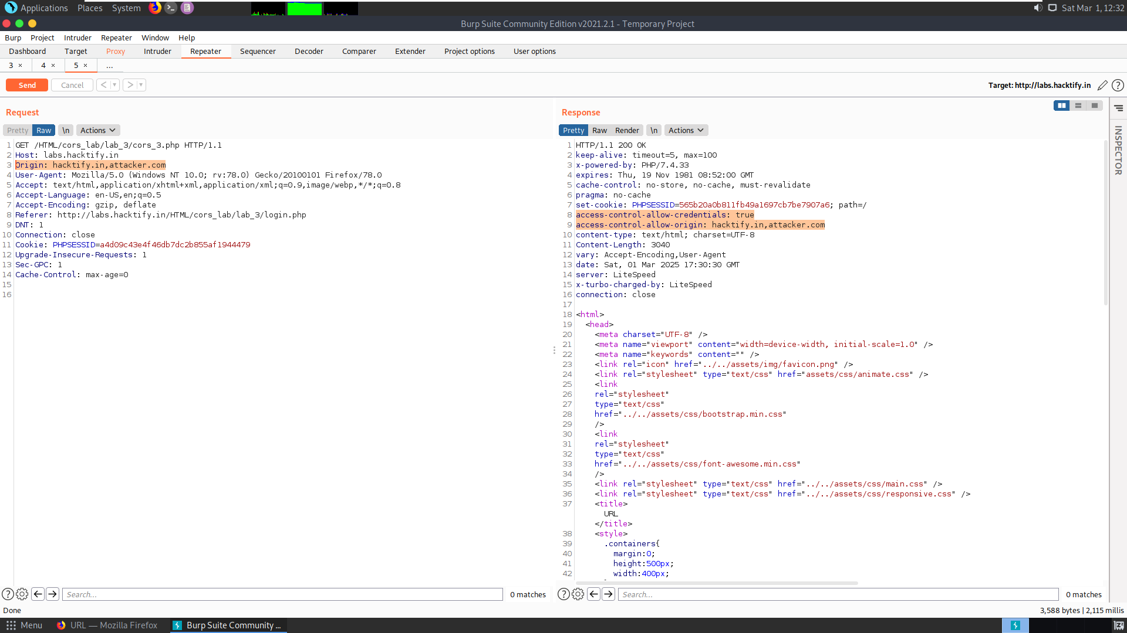

    - CORS with suffix match

Reference | Risk Rating
CORS With suffix match | Medium
Tools Used
Google Chrome and Burp Suite
Vulnerability Description
Cross-origin resource sharing (CORS) is a browser mechanism which enables controlled access to resources located outside of a given domain. It extends and adds flexibility to the same-origin policy. However, it also provides potential for cross-domain based attacks, if a website’s CORS policy is poorly configured and implemented. The CORS protocol uses some HTTP headers that define trusted web origins and associated properties such as whether authenticated access is permitted. Many modern websites use CORS to allow access from subdomains and trusted third parties. Sometimes because of mistakes of developers’ attackers can use misconfiguration to exploit vulnerability.
How It Was Discovered
I found this vulnerability by manually writing Origin payload by intercepting it in the Burp Suite.
Vulnerable URLs
https://labs.hacktify.in/HTML/cors_lab/lab_4/index.php
Consequences of not Fixing the Issue
Attackers would treat many victims to visit the attacker’s website, if victim is logged in, then his personal information is recorded on attacker's server. Attacker can perform any action in the user's account, bypassing CSRF tokes
Suggested Countermeasures
- Proper configuration of cross-domain requests : If a web resource contains sensitive information, the origin should be properly specified in the Access-Control-Allow-Origin header.
- Only allow trusted sites : Dynamically reflecting origins from cross-domain requests without validation is readily exploitable and should be voided.
- Avoid whitelisting null : Avoid using the header Access-Control-Allow-Origin: null . Cross-domain resource calls from internal documents and sandboxed requests can specify the null origin. CORS headers should be properly defined in respect of trusted origins for private and public servers.
- Avoid wildcards in internal networks : Avoid using wildcards in internal networks. Trusting network configuration alone to protect internal resources is not sufficient when internal browsers can access untrusted external domains.
References
- https://portswigger.net/web-security/cors
- https://owasp.org/www-community/attacks/CORS_OriginHeaderScrutiny
- https://developer.mozilla.org/en-US/docs/Web/HTTP/CORS
Payload Used
origin:evilhacktify.com

Proof of Concept
This section contains proof of the above vulnerabilities as the screenshot of the vulnerability of the lab.
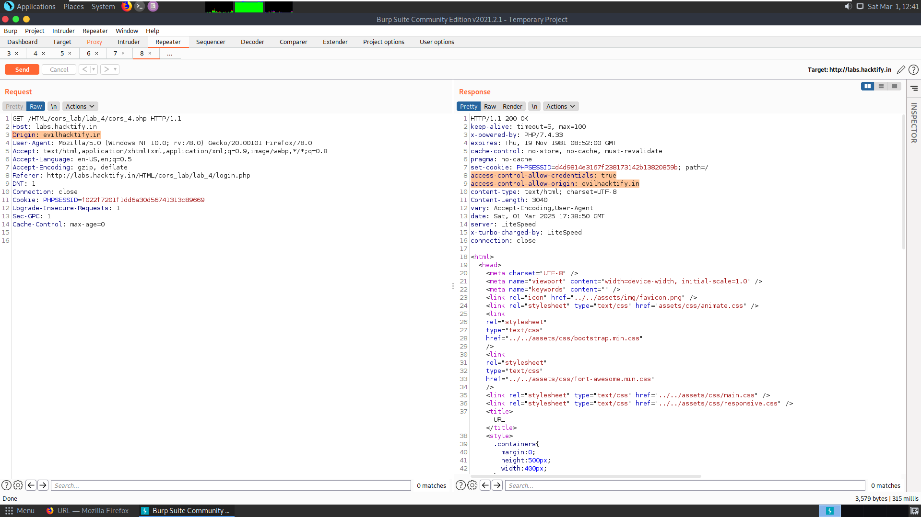

    - CORS with Escape dot

Reference | Risk Rating
CORS with Escape dot | High
Tools Used
Google Chrome and Burp Suite
Vulnerability Description
Cross-origin resource sharing (CORS) is a browser mechanism which enables controlled access to resources located outside of a given domain. It extends and adds flexibility to the same-origin policy. However, it also provides potential for cross-domain based attacks, if a website’s CORS policy is poorly configured and implemented. The CORS protocol uses some HTTP headers that define trusted web origins and associated properties such as whether authenticated access is permitted. Many modern websites use CORS to allow access from subdomains and trusted third parties. Sometimes because of mistakes of developers’ attackers can use misconfiguration to exploit vulnerability.
How It Was Discovered
I found this vulnerability by manually writing Origin payload by intercepting it in the Burp Suite.
Vulnerable URLs
https://labs.hacktify.in/HTML/cors_lab/lab_5/index.php
Consequences of not Fixing the Issue
Attackers would treat many victims to visit the attacker’s website, if victim is logged in, then his personal information is recorded on attacker's server. Attacker can perform any action in the user's account, bypassing CSRF tokes
Suggested Countermeasures
- Proper configuration of cross-domain requests : If a web resource contains sensitive information, the origin should be properly specified in the Access-Control-Allow-Origin header.
- Only allow trusted sites : Dynamically reflecting origins from cross-domain requests without validation is readily exploitable and should be voided.
- Avoid whitelisting null : Avoid using the header Access-Control-Allow-Origin: null . Cross-domain resource calls from internal documents and sandboxed requests can specify the null origin. CORS headers should be properly defined in respect of trusted origins for private and public servers.
- Avoid wildcards in internal networks : Avoid using wildcards in internal networks. Trusting network configuration alone to protect internal resources is not sufficient when internal browsers can access untrusted external domains.
References
- https://portswigger.net/web-security/cors
- https://owasp.org/www-community/attacks/CORS_OriginHeaderScrutiny
- https://developer.mozilla.org/en-US/docs/Web/HTTP/CORS
Payload Used
origin:wwwhacktify.in

Proof of Concept
This section contains proof of the above vulnerabilities as the screenshot of the vulnerability of the lab.
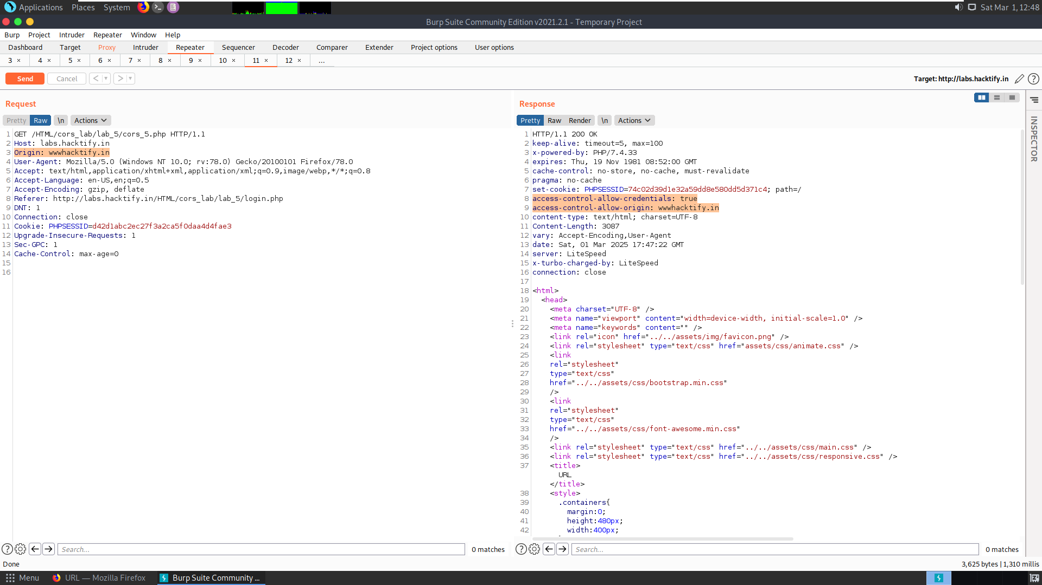

    - CORS with Substring match

Reference | Risk Rating
CORS with Substring match | High
Tools Used
Google Chrome and Burp Suite
Vulnerability Description
Cross-origin resource sharing (CORS) is a browser mechanism which enables controlled access to resources located outside of a given domain. It extends and adds flexibility to the same-origin policy. However, it also provides potential for cross-domain based attacks, if a website’s CORS policy is poorly configured and implemented. The CORS protocol uses some HTTP headers that define trusted web origins and associated properties such as whether authenticated access is permitted. Many modern websites use CORS to allow access from subdomains and trusted third parties. Sometimes because of mistakes of developers’ attackers can use misconfiguration to exploit vulnerability.
How It Was Discovered
I found this vulnerability by manually writing Origin payload by intercepting it in the Burp Suite.
Vulnerable URLs
https://labs.hacktify.in/HTML/cors_lab/lab_6/index.php
Consequences of not Fixing the Issue
Attackers would treat many victims to visit the attacker’s website, if victim is logged in, then his personal information is recorded on attacker's server. Attacker can perform any action in the user's account, bypassing CSRF tokes
Suggested Countermeasures
- Proper configuration of cross-domain requests : If a web resource contains sensitive information, the origin should be properly specified in the Access-Control-Allow-Origin header.
- Only allow trusted sites : Dynamically reflecting origins from cross-domain requests without validation is readily exploitable and should be voided.
- Avoid whitelisting null : Avoid using the header Access-Control-Allow-Origin: null . Cross-domain resource calls from internal documents and sandboxed requests can specify the null origin. CORS headers should be properly defined in respect of trusted origins for private and public servers.
- Avoid wildcards in internal networks : Avoid using wildcards in internal networks. Trusting network configuration alone to protect internal resources is not sufficient when internal browsers can access untrusted external domains.
References
- https://portswigger.net/web-security/cors
- https://owasp.org/www-community/attacks/CORS_OriginHeaderScrutiny
- https://developer.mozilla.org/en-US/docs/Web/HTTP/CORS
Payload Used
origin:hacktify.com

Proof of Concept
This section contains proof of the above vulnerabilities as the screenshot of the vulnerability of the lab.
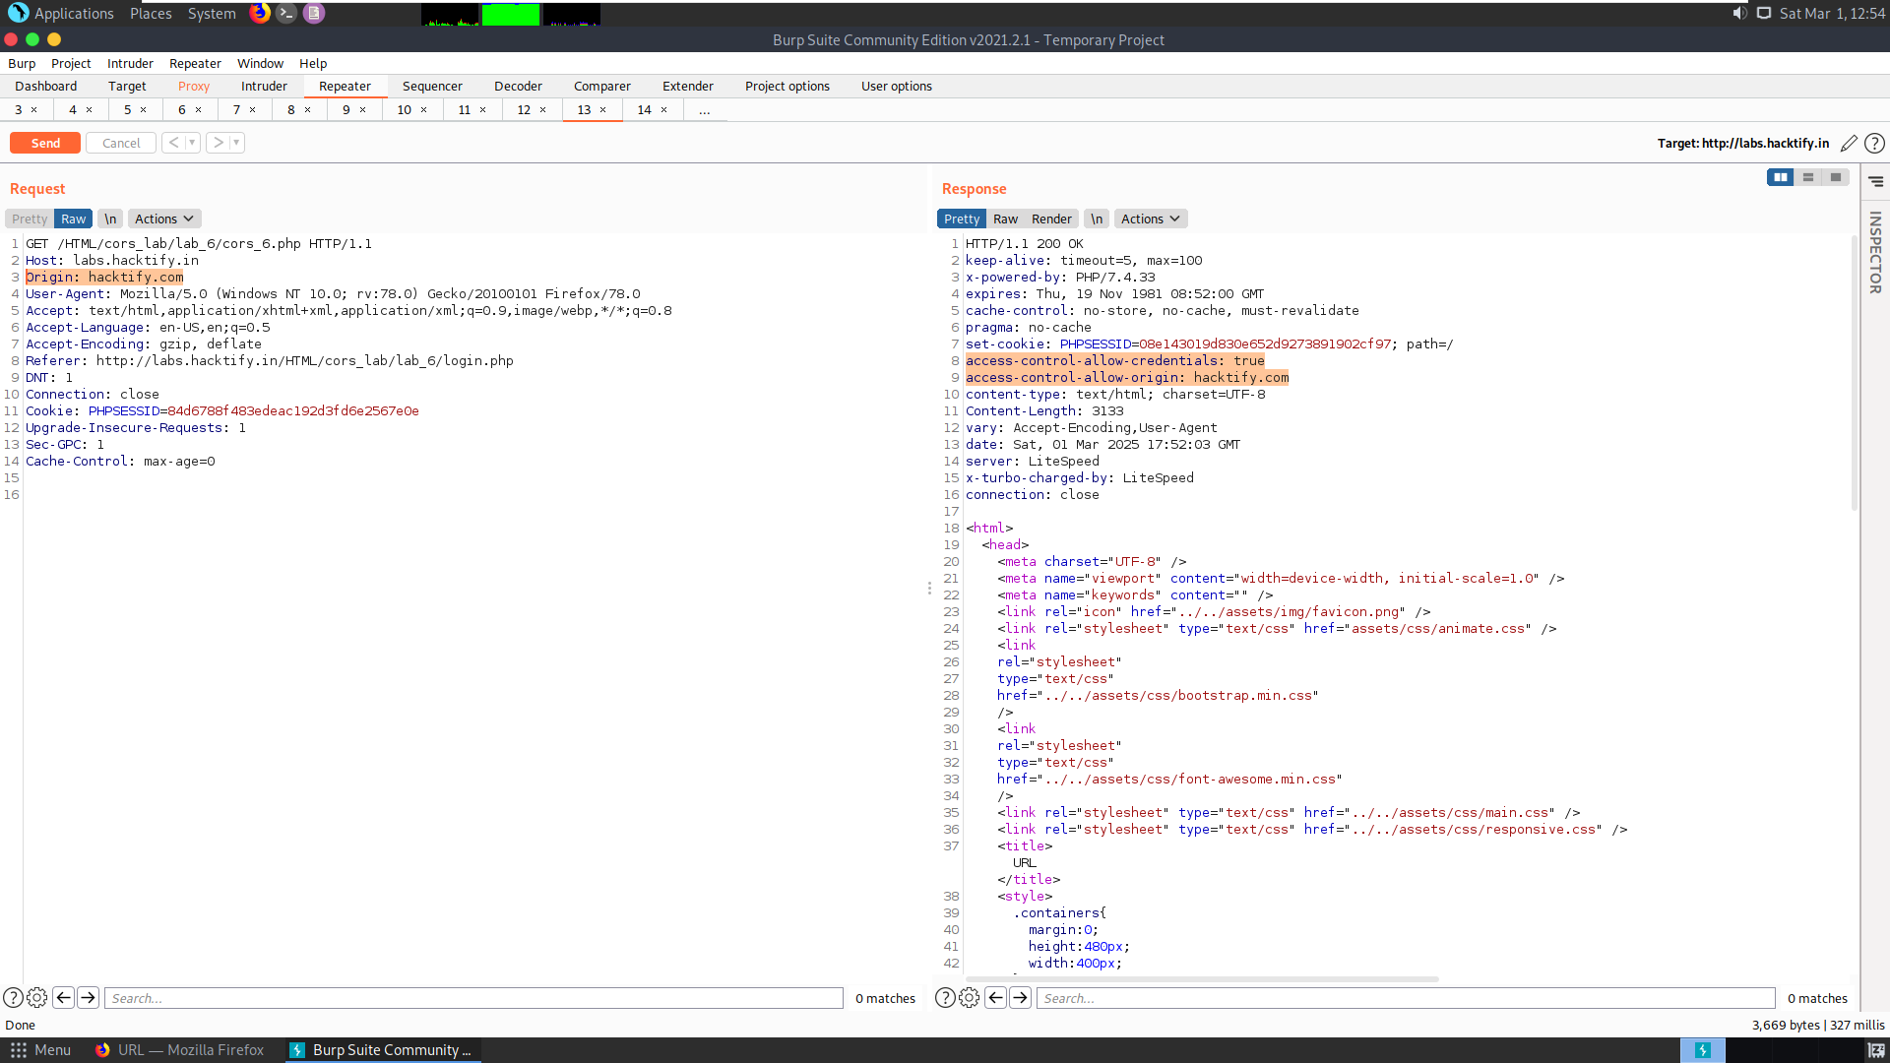

    - CORS with Arbitrary Subdomain

Reference | Risk Rating
CORS with Arbitrary Subdomain | High
Tools Used
Google Chrome and Burp Suite
Vulnerability Description
Cross-origin resource sharing (CORS) is a browser mechanism which enables controlled access to resources located outside of a given domain. It extends and adds flexibility to the same-origin policy. However, it also provides potential for cross-domain based attacks, if a website’s CORS policy is poorly configured and implemented. The CORS protocol uses some HTTP headers that define trusted web origins and associated properties such as whether authenticated access is permitted. Many modern websites use CORS to allow access from subdomains and trusted third parties. Sometimes because of mistakes of developers’ attackers can use misconfiguration to exploit vulnerability.
How It Was Discovered
I found this vulnerability by manually writing Origin payload by intercepting it in the Burp Suite.
Vulnerable URLs
https://labs.hacktify.in/HTML/cors_lab/lab_7/index.php
Consequences of not Fixing the Issue
Attackers would treat many victims to visit the attacker’s website, if victim is logged in, then his personal information is recorded on attacker's server. Attacker can perform any action in the user's account, bypassing CSRF tokes
Suggested Countermeasures
- Proper configuration of cross-domain requests : If a web resource contains sensitive information, the origin should be properly specified in the Access-Control-Allow-Origin header.
- Only allow trusted sites : Dynamically reflecting origins from cross-domain requests without validation is readily exploitable and should be voided.
- Avoid whitelisting null : Avoid using the header Access-Control-Allow-Origin: null . Cross-domain resource calls from internal documents and sandboxed requests can specify the null origin. CORS headers should be properly defined in respect of trusted origins for private and public servers.
- Avoid wildcards in internal networks : Avoid using wildcards in internal networks. Trusting network configuration alone to protect internal resources is not sufficient when internal browsers can access untrusted external domains.
References
- https://portswigger.net/web-security/cors
- https://owasp.org/www-community/attacks/CORS_OriginHeaderScrutiny
- https://developer.mozilla.org/en-US/docs/Web/HTTP/CORS
Payload Used
origin:evil.hacktify.in

Proof of Concept
This section contains proof of the above vulnerabilities as the screenshot of the vulnerability of the lab.
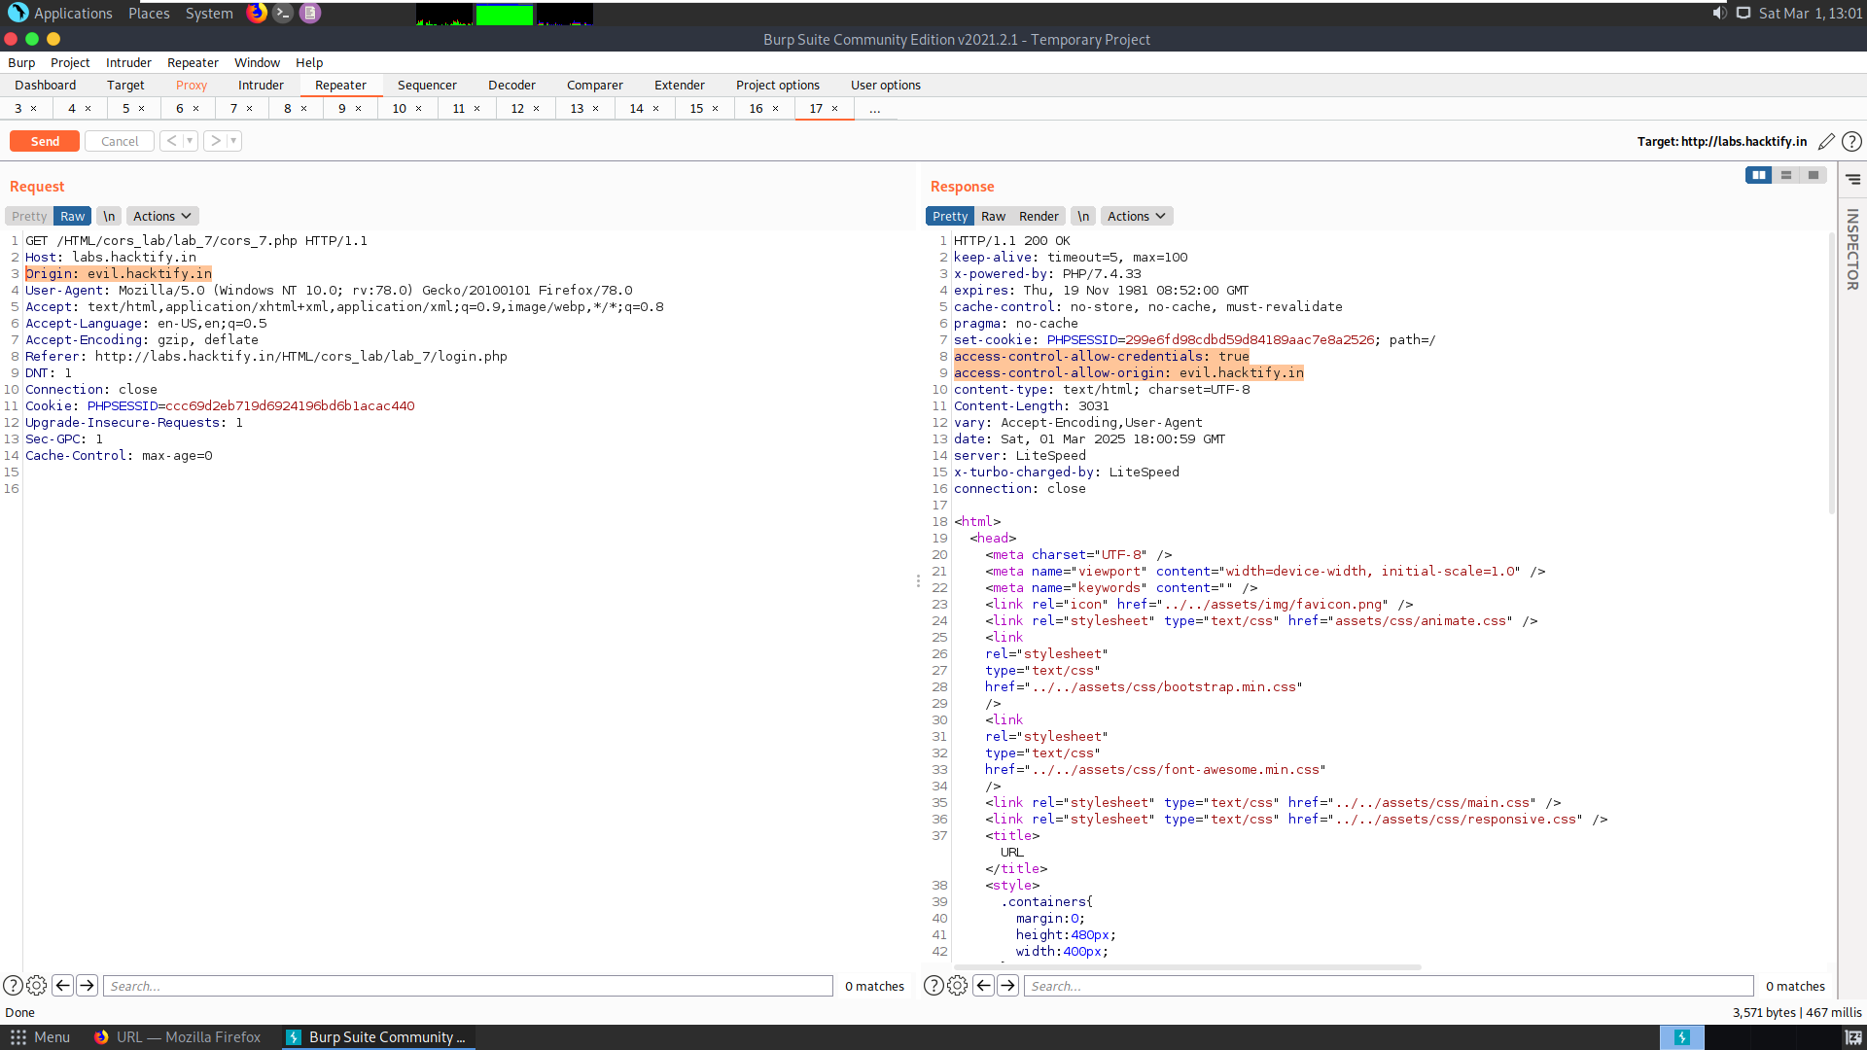

  - Cross-Site Request Forgery (CSRF)
    - Eassyy CSRF

Reference | Risk Rating
Eassyy CSRF | Low
Tools Used
Google chrome and Burp Suite
Vulnerability Description
Cross-Site Request Forgery (CSRF) is an attack that forces an end user to execute unwanted
actions on a web application in which they’re currently authenticated. With a little help of social
engineering an attacker may trick the users of a web application into executing actions of the
attacker’s choosing. If the victim is a normal user, a successful CSRF attack can force the user to
perform state changing requests like transferring funds, changing their email address, and so
forth. If the victim is an administrative account, CSRF can compromise the entire web
application.
How It Was Discovered
I found this vulnerability by generating CSRF POCs of forged URL and sending it to the victim.
Vulnerable URLs
https://labs.hacktify.in/HTML/csrf_lab/lab_1/passwordChange.php
Consequences of not Fixing the Issue
In a successful CSRF attack, the attacker causes the victim user to carry out an action
unintentionally. Depending on the nature of the action, the attacker might be able to gain full
control over the user's account. If the compromised user has a privileged role within the
application, then the attacker might be able to take full control of all the application's data and
functionality
Suggested Countermeasures
- Anti-CSRF Tokens: Use a token that is associated with a particular user and can be found as
a hidden value in every state changing form which is present on the web application. This
token, called a CSRF Token or a Synchronizer Token.
- Same Site Cookies: CSRF attacks are only possible since Cookies are always sent with any
requests that are sent to a particular origin, which is related to that Cookie. Due to the nature
of a CSRF attack, a flag can be set against a Cookie, turning it into a same-site Cookie. A same-site Cookie is a Cookie which can only be sent, if the request is being made from the
same origin that is related to the Cookie being sent.
References
- https://portswigger.net/web-security/csrf
- https://owasp.org/www-community/attacks/csrf
- https://www.acunetix.com/websitesecurity/csrf-attacks/
Payload Used
Generated CSRF POC using Burp Suite and changed the password to “abcd” followed by sending the URL to victim user. Logged in into the system as victim user, followed by hitting submit button from it.

Proof of Concept
This section contains proof of the above vulnerabilities as the screenshot of the vulnerability of the lab.
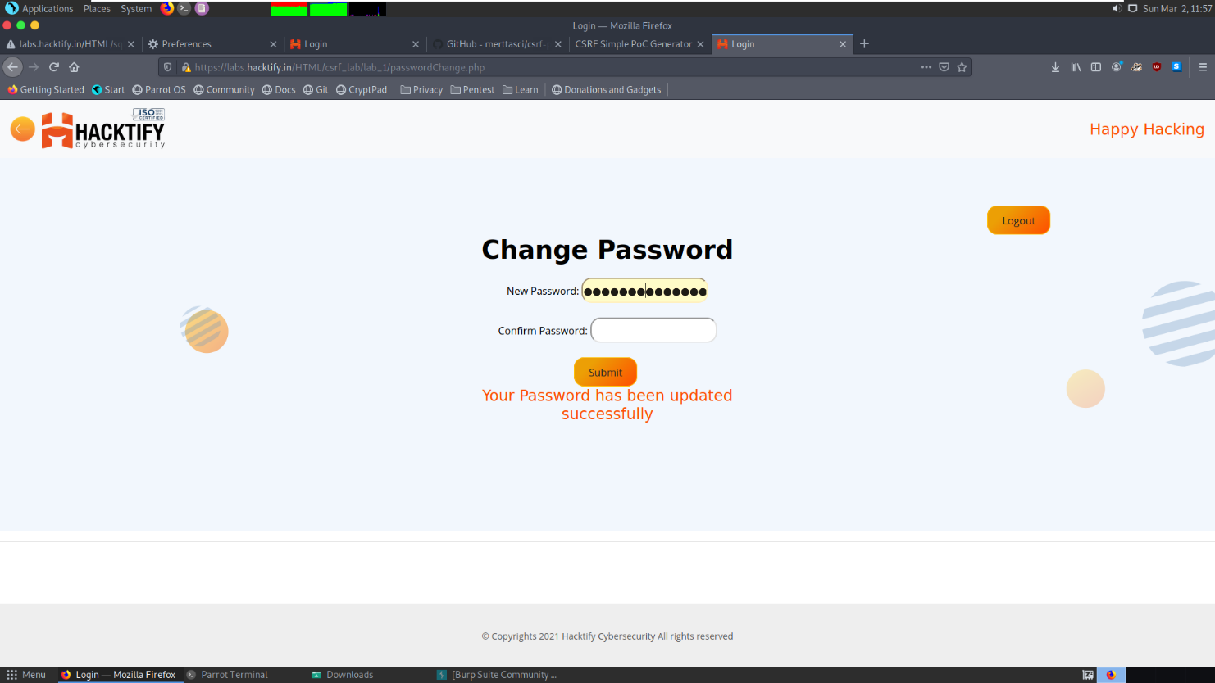

    - Always Validate Tokens

Reference | Risk Rating
Always Validate Tokens | Medium
Tools Used
Google Chrome and Burp Suite
Vulnerability Description
Cross-Site Request Forgery (CSRF) is an attack that forces an end user to execute unwanted
actions on a web application in which they’re currently authenticated. With a little help of social
engineering an attacker may trick the users of a web application into executing actions of the
attacker’s choosing. If the victim is a normal user, a successful CSRF attack can force the user to
perform state changing requests like transferring funds, changing their email address, and so
forth. If the victim is an administrative account, CSRF can compromise the entire web
application.
How It Was Discovered
I found this vulnerability by generating CSRF POCs of forged URL and sending it to the victim.
Vulnerable URLs
https://labs.hacktify.in/HTML/csrf_lab/lab_2/passwordChange.php
Consequences of not Fixing the Issue
In a successful CSRF attack, the attacker causes the victim user to carry out an action
unintentionally. Depending on the nature of the action, the attacker might be able to gain full
control over the user's account. If the compromised user has a privileged role within the
application, then the attacker might be able to take full control of all the application's data and
functionality
Suggested Countermeasures
- Anti-CSRF Tokens: Use a token that is associated with a particular user and can be found as
a hidden value in every state changing form which is present on the web application. This
token, called a CSRF Token or a Synchronizer Token.
- Same Site Cookies: CSRF attacks are only possible since Cookies are always sent with any
requests that are sent to a particular origin, which is related to that Cookie. Due to the nature
of a CSRF attack, a flag can be set against a Cookie, turning it into a same-site Cookie. A same-site Cookie is a Cookie which can only be sent, if the request is being made from the
same origin that is related to the Cookie being sent.
References
- https://portswigger.net/web-security/csrf
- https://owasp.org/www-community/attacks/csrf
- https://www.acunetix.com/websitesecurity/csrf-attacks/
Payload Used
Generated CSRF POC using Burp Suite and changed the password to “abcd” followed by sending the URL to victim user. Logged in into the system as victim user, followed by hitting submit button from it.

Proof of Concept
This section contains proof of the above vulnerabilities as the screenshot of the vulnerability of the lab.
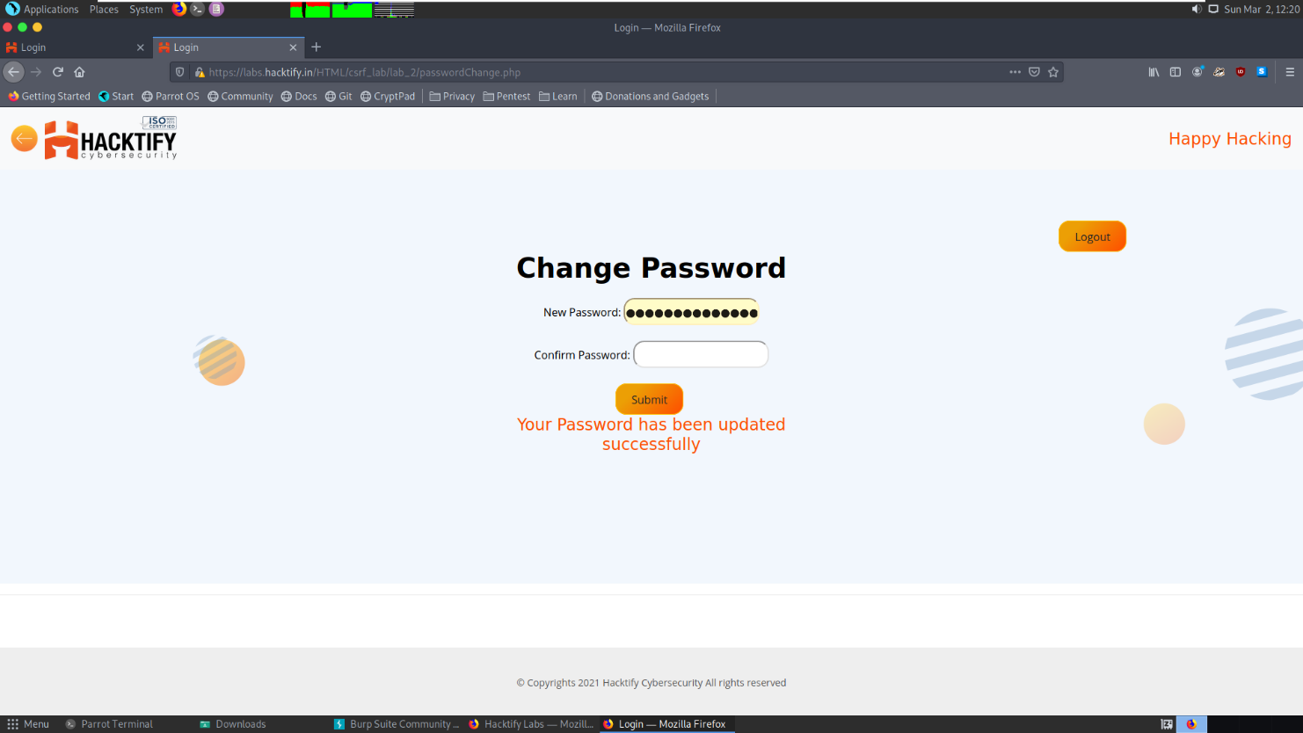

    - I hate when someone uses my tokens!

Reference | Risk Rating
I hate when someone uses my tokens! | Medium
Tools Used
Google Chrome and Burp Suite
Vulnerability Description
Cross-Site Request Forgery (CSRF) is an attack that forces an end user to execute unwanted
actions on a web application in which they’re currently authenticated. With a little help of social
engineering an attacker may trick the users of a web application into executing actions of the
attacker’s choosing. If the victim is a normal user, a successful CSRF attack can force the user to
perform state changing requests like transferring funds, changing their email address, and so
forth. If the victim is an administrative account, CSRF can compromise the entire web
application.
How It Was Discovered
I found this vulnerability by generating CSRF POCs of forged URL and sending it to the victim.
Vulnerable URLs
https://labs.hacktify.in/HTML/csrf_lab/lab_4/passwordChange.php
Consequences of not Fixing the Issue
In a successful CSRF attack, the attacker causes the victim user to carry out an action
unintentionally. Depending on the nature of the action, the attacker might be able to gain full
control over the user's account. If the compromised user has a privileged role within the
application, then the attacker might be able to take full control of all the application's data and
functionality
Suggested Countermeasures
- Anti-CSRF Tokens: Use a token that is associated with a particular user and can be found as a hidden value in every state changing form which is present on the web application. This token, called a CSRF Token or a Synchronizer Token.
- Same Site Cookies: CSRF attacks are only possible since Cookies are always sent with any
requests that are sent to a particular origin, which is related to that Cookie. Due to the nature of a CSRF attack, a flag can be set against a Cookie, turning it into a same-site Cookie. A same-site Cookie is a Cookie which can only be sent, if the request is being made from the same origin that is related to the Cookie being sent.
References
- https://portswigger.net/web-security/csrf
- https://owasp.org/www-community/attacks/csrf
- https://www.acunetix.com/websitesecurity/csrf-attacks/
Payload Used
Generated CSRF POC using Burp Suite and changed the password to “abcd” followed by sending the URL to victim user. Logged in into the system as victim user, followed by hitting submit button from it.

Proof of Concept
This section contains proof of the above vulnerabilities as the screenshot of the vulnerability of the lab.
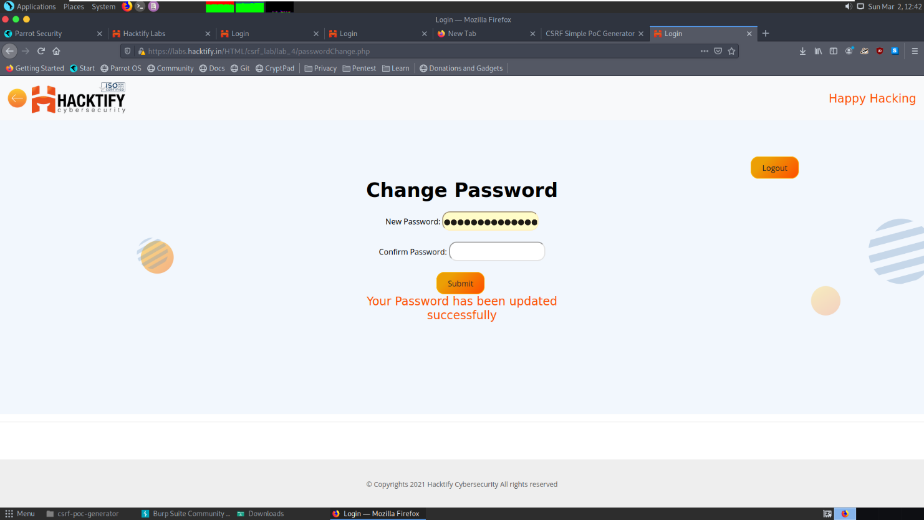

    - GET Me or POST ME

Reference | Risk Rating
GET Me or POST ME | Low
Tools Used
Google Chrome and Burp Suite
Vulnerability Description
Cross-Site Request Forgery (CSRF) is an attack that forces an end user to execute unwanted
actions on a web application in which they’re currently authenticated. With a little help of social
engineering an attacker may trick the users of a web application into executing actions of the
attacker’s choosing. If the victim is a normal user, a successful CSRF attack can force the user to
perform state changing requests like transferring funds, changing their email address, and so
forth. If the victim is an administrative account, CSRF can compromise the entire web
application.
How It Was Discovered
I found this vulnerability by generating CSRF POCs of forged URL and sending it to the victim.
Vulnerable URLs
https://labs.hacktify.in/HTML/csrf_lab/lab_6/passwordChange.php
Consequences of not Fixing the Issue
In a successful CSRF attack, the attacker causes the victim user to carry out an action
unintentionally. Depending on the nature of the action, the attacker might be able to gain full
control over the user's account. If the compromised user has a privileged role within the
application, then the attacker might be able to take full control of all the application's data and
functionality
Suggested Countermeasures
- Anti-CSRF Tokens: Use a token that is associated with a particular user and can be found as a hidden value in every state changing form which is present on the web application. This token, called a CSRF Token or a Synchronizer Token.
- Same Site Cookies: CSRF attacks are only possible since Cookies are always sent with any
requests that are sent to a particular origin, which is related to that Cookie. Due to the nature of a CSRF attack, a flag can be set against a Cookie, turning it into a same-site Cookie. A same-site Cookie is a Cookie which can only be sent, if the request is being made from the same origin that is related to the Cookie being sent.
References
- https://portswigger.net/web-security/csrf
- https://owasp.org/www-community/attacks/csrf
- https://www.acunetix.com/websitesecurity/csrf-attacks/
Payload Used
Generated CSRF POC using Burp Suite and changed the password to “abcd” followed by sending the URL to victim user. Logged in into the system as victim user, followed by hitting submit button from it.

Proof of Concept
This section contains proof of the above vulnerabilities as the screenshot of the vulnerability of the lab.
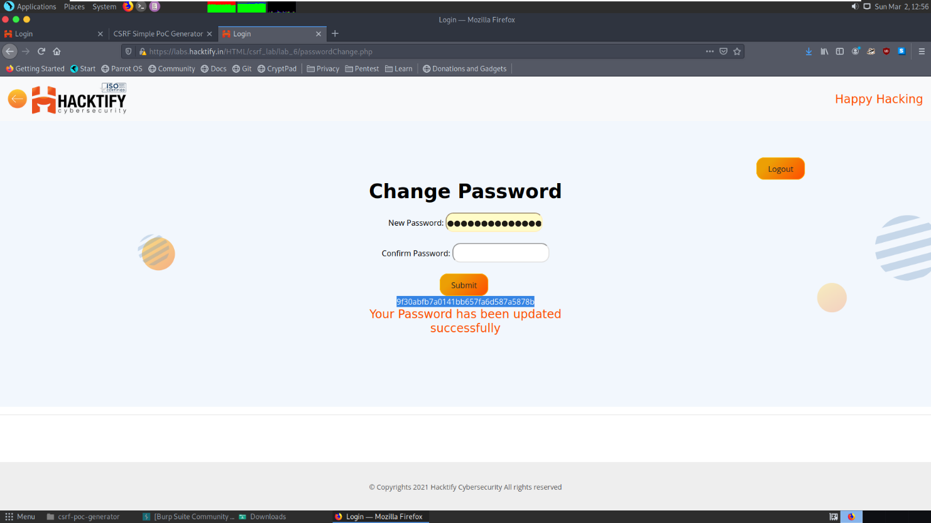

    - XSS the saviour

Reference | Risk Rating
XSS the saviour | Low
Tools Used
Google Chrome and Burp Suite
Vulnerability Description
Cross-Site Request Forgery (CSRF) is an attack that forces an end user to execute unwanted
actions on a web application in which they’re currently authenticated. With a little help of social
engineering an attacker may trick the users of a web application into executing actions of the
attacker’s choosing. If the victim is a normal user, a successful CSRF attack can force the user to
perform state changing requests like transferring funds, changing their email address, and so
forth. If the victim is an administrative account, CSRF can compromise the entire web
application.
How It Was Discovered
I found this vulnerability by generating CSRF POCs of forged URL and sending it to the victim.
Vulnerable URLs
http://labs.hacktify.in/HTML/csrf_lab/lab_7/lab_7.php?name=%3Cscript%3Ealert%28document.cookie%29%3C%2Fscript%3E&show=Save
Consequences of not Fixing the Issue
In a successful CSRF attack, the attacker causes the victim user to carry out an action
unintentionally. Depending on the nature of the action, the attacker might be able to gain full
control over the user's account. If the compromised user has a privileged role within the
application, then the attacker might be able to take full control of all the application's data and
functionality
Suggested Countermeasures
- Anti-CSRF Tokens: Use a token that is associated with a particular user and can be found as a hidden value in every state changing form which is present on the web application. This token, called a CSRF Token or a Synchronizer Token.
- Same Site Cookies: CSRF attacks are only possible since Cookies are always sent with any
requests that are sent to a particular origin, which is related to that Cookie. Due to the nature of a CSRF attack, a flag can be set against a Cookie, turning it into a same-site Cookie. A same-site Cookie is a Cookie which can only be sent, if the request is being made from the same origin that is related to the Cookie being sent.
References
- https://portswigger.net/web-security/csrf
- https://owasp.org/www-community/attacks/csrf
- https://www.acunetix.com/websitesecurity/csrf-attacks/
Payload Used
<script>alert(document.cookie)</script>

Proof of Concept
This section contains proof of the above vulnerabilities as the screenshot of the vulnerability of the lab.
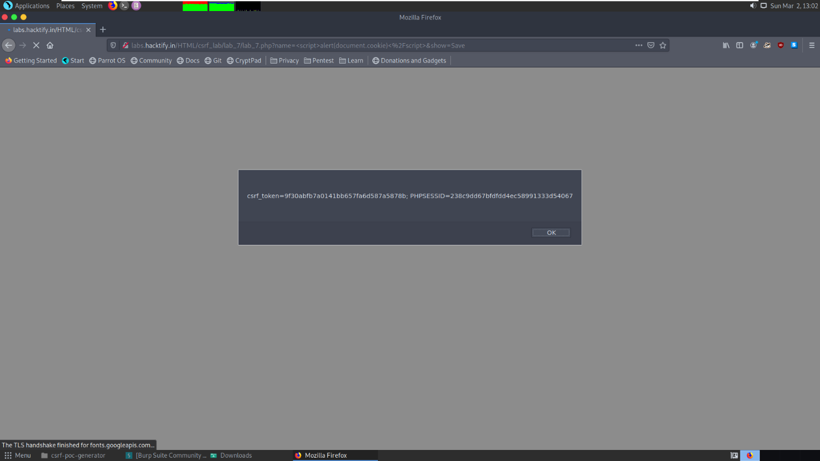

    - rm -rf token

Reference | Risk Rating
rm -rf token | Low
Tools Used
Google Chrome and Burp Suite
Vulnerability Description
Cross-Site Request Forgery (CSRF) is an attack that forces an end user to execute unwanted
actions on a web application in which they’re currently authenticated. With a little help of social
engineering an attacker may trick the users of a web application into executing actions of the
attacker’s choosing. If the victim is a normal user, a successful CSRF attack can force the user to
perform state changing requests like transferring funds, changing their email address, and so
forth. If the victim is an administrative account, CSRF can compromise the entire web
application.
How It Was Discovered
I found this vulnerability by generating CSRF POCs of forged URL and sending it to the victim.
Vulnerable URLs
https://labs.hacktify.in/HTML/csrf_lab/lab_8/passwordChange.php
Consequences of not Fixing the Issue
In a successful CSRF attack, the attacker causes the victim user to carry out an action
unintentionally. Depending on the nature of the action, the attacker might be able to gain full
control over the user's account. If the compromised user has a privileged role within the
application, then the attacker might be able to take full control of all the application's data and
functionality
Suggested Countermeasures
- Anti-CSRF Tokens: Use a token that is associated with a particular user and can be found as a hidden value in every state changing form which is present on the web application. This token, called a CSRF Token or a Synchronizer Token.
- Same Site Cookies: CSRF attacks are only possible since Cookies are always sent with any
requests that are sent to a particular origin, which is related to that Cookie. Due to the nature of a CSRF attack, a flag can be set against a Cookie, turning it into a same-site Cookie. A same-site Cookie is a Cookie which can only be sent, if the request is being made from the same origin that is related to the Cookie being sent.
References
- https://portswigger.net/web-security/csrf
- https://owasp.org/www-community/attacks/csrf
- https://www.acunetix.com/websitesecurity/csrf-attacks/
Payload Used
Generated CSRF POC using Burp Suite and changed the password to “abcd” followed by sending the URL to victim user. Logged in into the system as victim user, followed by hitting submit button from it.

Proof of Concept
This section contains proof of the above vulnerabilities as the screenshot of the vulnerability of the lab.
